**Project - Phase III: Dashboard Implementation– Team 23**

**Kartheek Panyam & Gokuleswar Reddy Mooli**

**Arun Pal Bommaji & Maneesh Reddy Devara**

MS IN INFORMATION TECHNOLOGY, ARIZONA STATE UNIVERSITY

**IFT 533: Data Visualization & Reporting for IT**

**PROF. ASMAA ELBADRAWY**

May 02, 2025

**Section 1: The Dashboard**

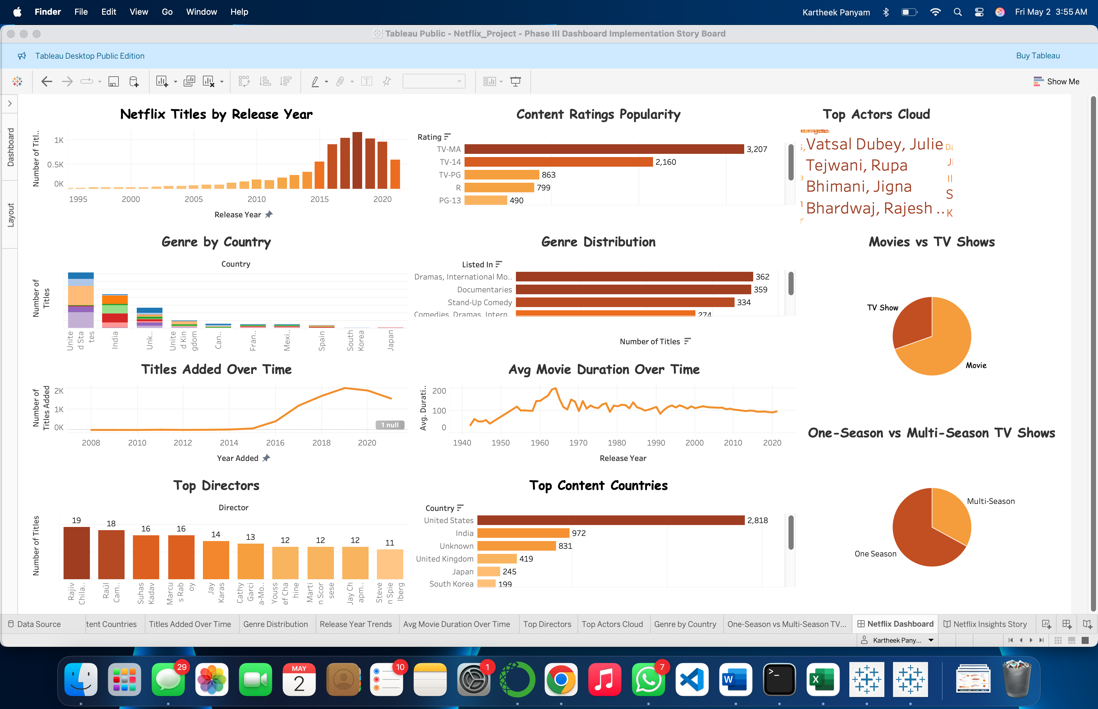

Our final dashboard, crafted in Tableau Public, seamlessly integrates 11 rich visualizations from the Netflix Movies and TV Shows dataset. This dashboard serves as a powerful tool for delving into trends in content types, release patterns, genres, and contributors, including directors and actors. Moreover, it facilitates country-wise analysis and comparisons based on ratings and seasons.

The dashboard empowers users to explore user-driven questions, such as identifying the dominant genres on Netflix, identifying the most featured actors, and understanding the evolution of Netflix’s content over time. Each visual element incorporates interactive filtering and adheres to clean, rubric-aligned design principles.

**Section 2: The Dataset**

We used the Netflix Movies and TV Shows dataset from Kaggle, containing 8,807 titles with fields including title, type, director, cast, country, date_added, release_year, rating, duration, and listed_in (genres).

**Key preprocessing steps:**

* Missing values (in cast, director, country) were filled with 'Unknown'.
* date_added was converted to datetime, and year_added/month_added extracted.
* duration was normalized into minutes (for movies) or season counts (for TV shows).
* listed_in was split for genre analysis.
* The cast field was exploded into individual actors for frequency analysis.
* A cleaned dataset (netflix_titles_cleaned.csv) was created using Python (Pandas) and used in Tableau.

**The code used for python preprocessing is as follows:**

import pandas as pd

# Load the dataset

df = pd.read_csv('netflix_titles.csv')

# Fix missing values

df['director'] = df['director'].fillna('Unknown')

df['cast'] = df['cast'].fillna('Unknown')

df['country'] = df['country'].fillna('Unknown')

# Convert 'date_added' to datetime

df['date_added'] = pd.to_datetime(df['date_added'], errors='coerce')

df['year_added'] = df['date_added'].dt.year

df['month_added'] = df['date_added'].dt.month

# Normalize duration

df['duration_minutes'] = df['duration'].str.extract(r'(\d+)').astype(float)

df['seasons'] = df['duration'].apply(lambda x: float(x.split(' ')[0]) if isinstance(x, str) and 'Season' in x else None)

# Split genres

df['genres'] = df['listed_in'].str.split(', ')

# Save cleaned dataset

df.to_csv('netflix_titles_cleaned.csv', index=False)

print("Cleaned data saved as 'netflix_titles_cleaned.csv'")

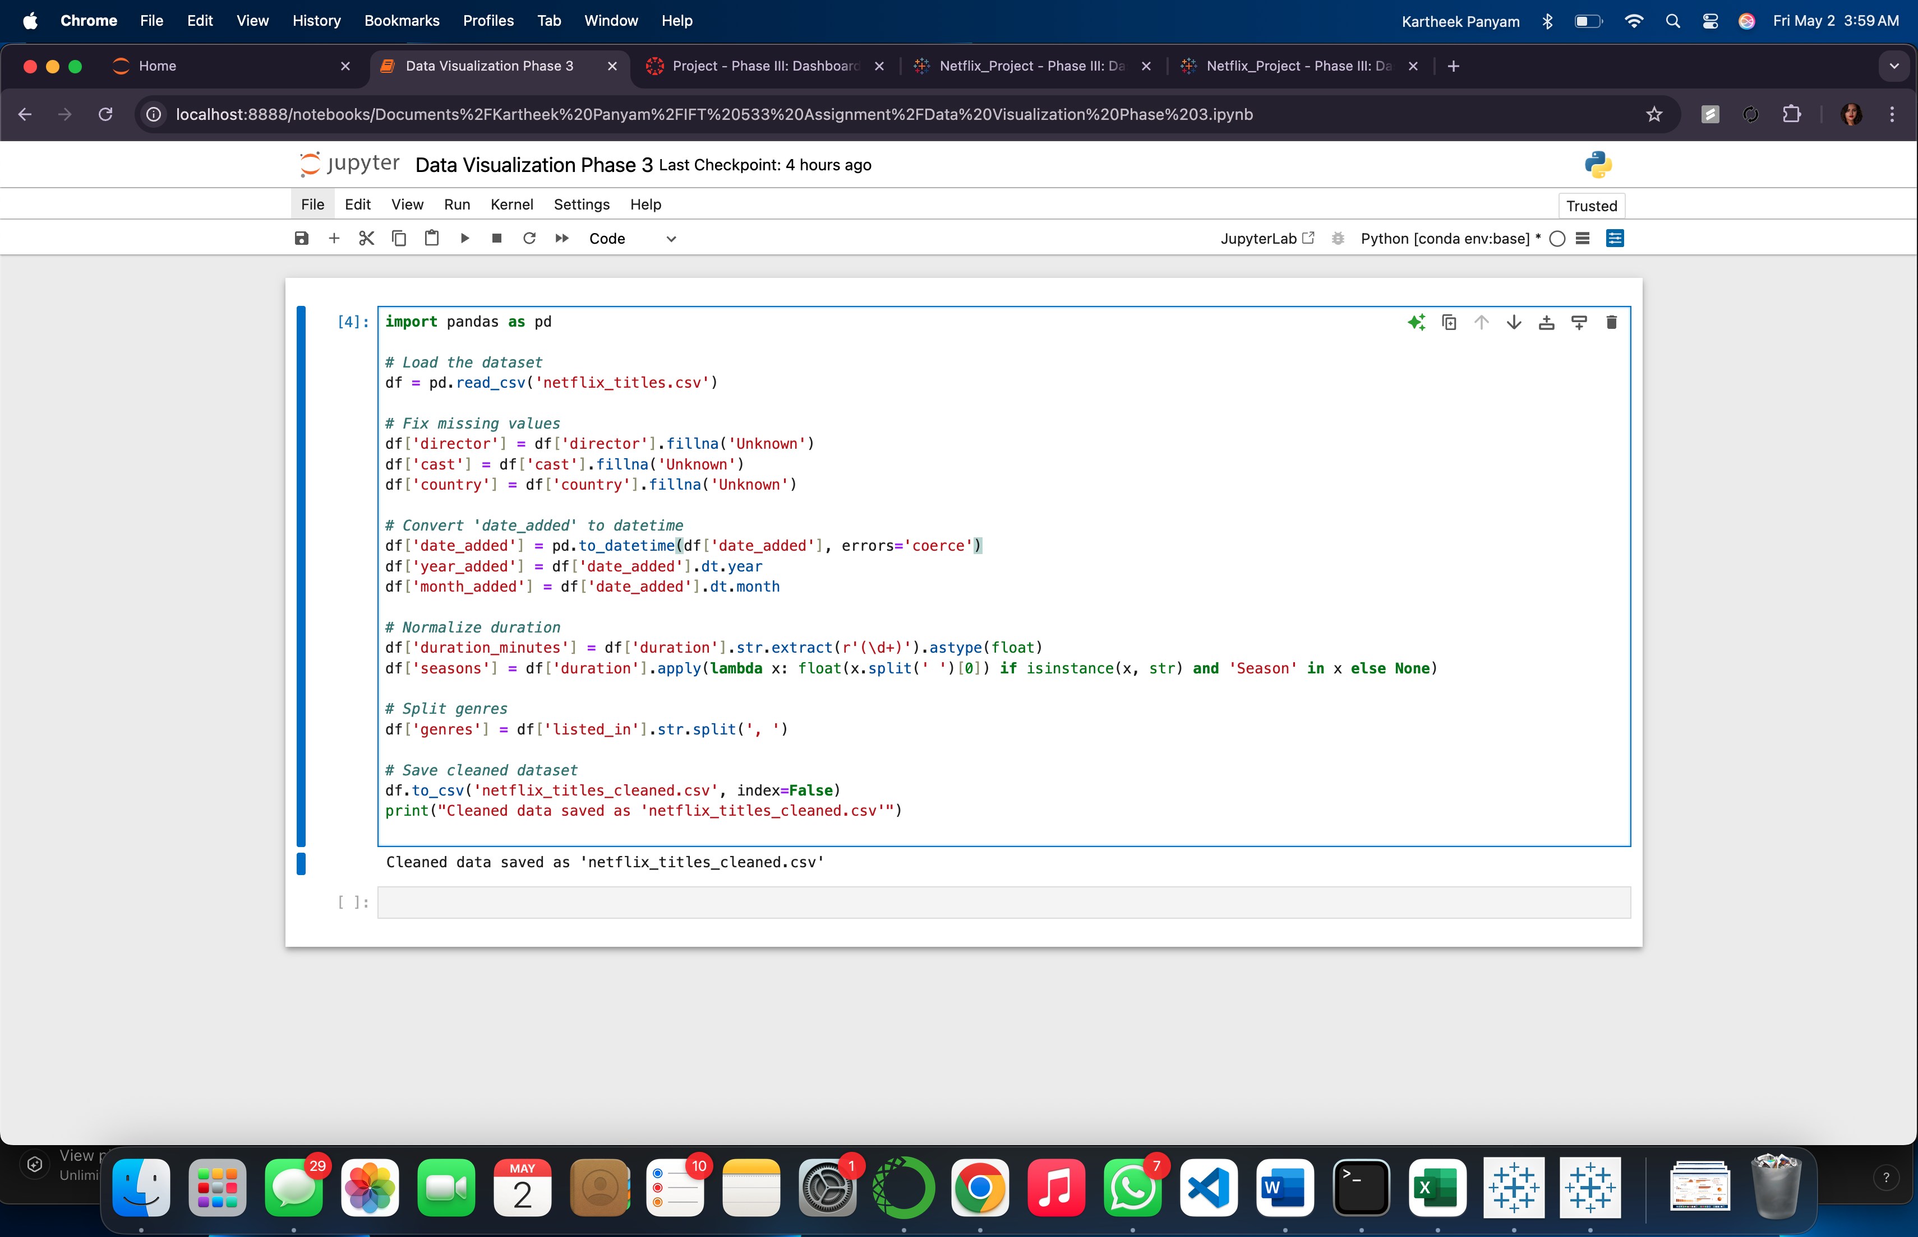

**Section 3: Dashboard Users**

The dashboard is designed for multiple users:

* **Content Strategists at Streaming Platforms**: They can analyze trends in content types, genres, and release years to identify what kind of content is in demand and which categories are underrepresented.
* **Entertainment Data Analysts**: These users would benefit from visualizing metrics like the rise of international content, popularity of TV shows vs. movies, or shifts in genre trends over time.
* **Marketing and Audience Engagement Teams**: By understanding content distribution across countries, ratings, and genres, marketing professionals can tailor campaigns to different audience segments more effectively.
* **Production Companies & Studios**: They can use the dashboard to study competitor content strategies, identify popular themes, and spot market gaps for new productions.
* **Academic Researchers and Media Students**: Useful for analyzing global media trends, cultural representation, and shifts in public viewing preferences based on rating and genre patterns.

**Section 4: Questions**

The dashboard is designed to allow users to explore and answer the following questions based on the Netflix Titles dataset:

1. How many movies vs. TV shows are currently available on Netflix?
2. What are the most popular content ratings (e.g., TV-MA, PG-13, R) on Netflix?
3. Which countries produce the most content available on Netflix?
4. How has the number of new titles added to Netflix changed over time (by year or month)?
5. What are the most common genres or genre combinations across all titles?
6. Which years had the highest number of releases?
7. What is the average duration of movies on Netflix? Are there noticeable trends by year or by content rating?
8. Which directors have the most titles featured on Netflix?
9. Which actors or actresses appear most frequently across Netflix content?
10. Are there genre preferences based on country (e.g., India vs. US vs. Japan)?
11. How are titles distributed across different maturity ratings by type (Movie vs. TV Show)?
12. Are more international titles being added to Netflix in recent years compared to earlier years?
13. How many one-season vs. multi-season TV shows are available on Netflix?
14. What genres are most common among TV shows compared to movies?
15. Top 10 most represented countries in each genre?

**Section 5: Plots**

1. **Movies vs TV Shows (Pie Chart)**

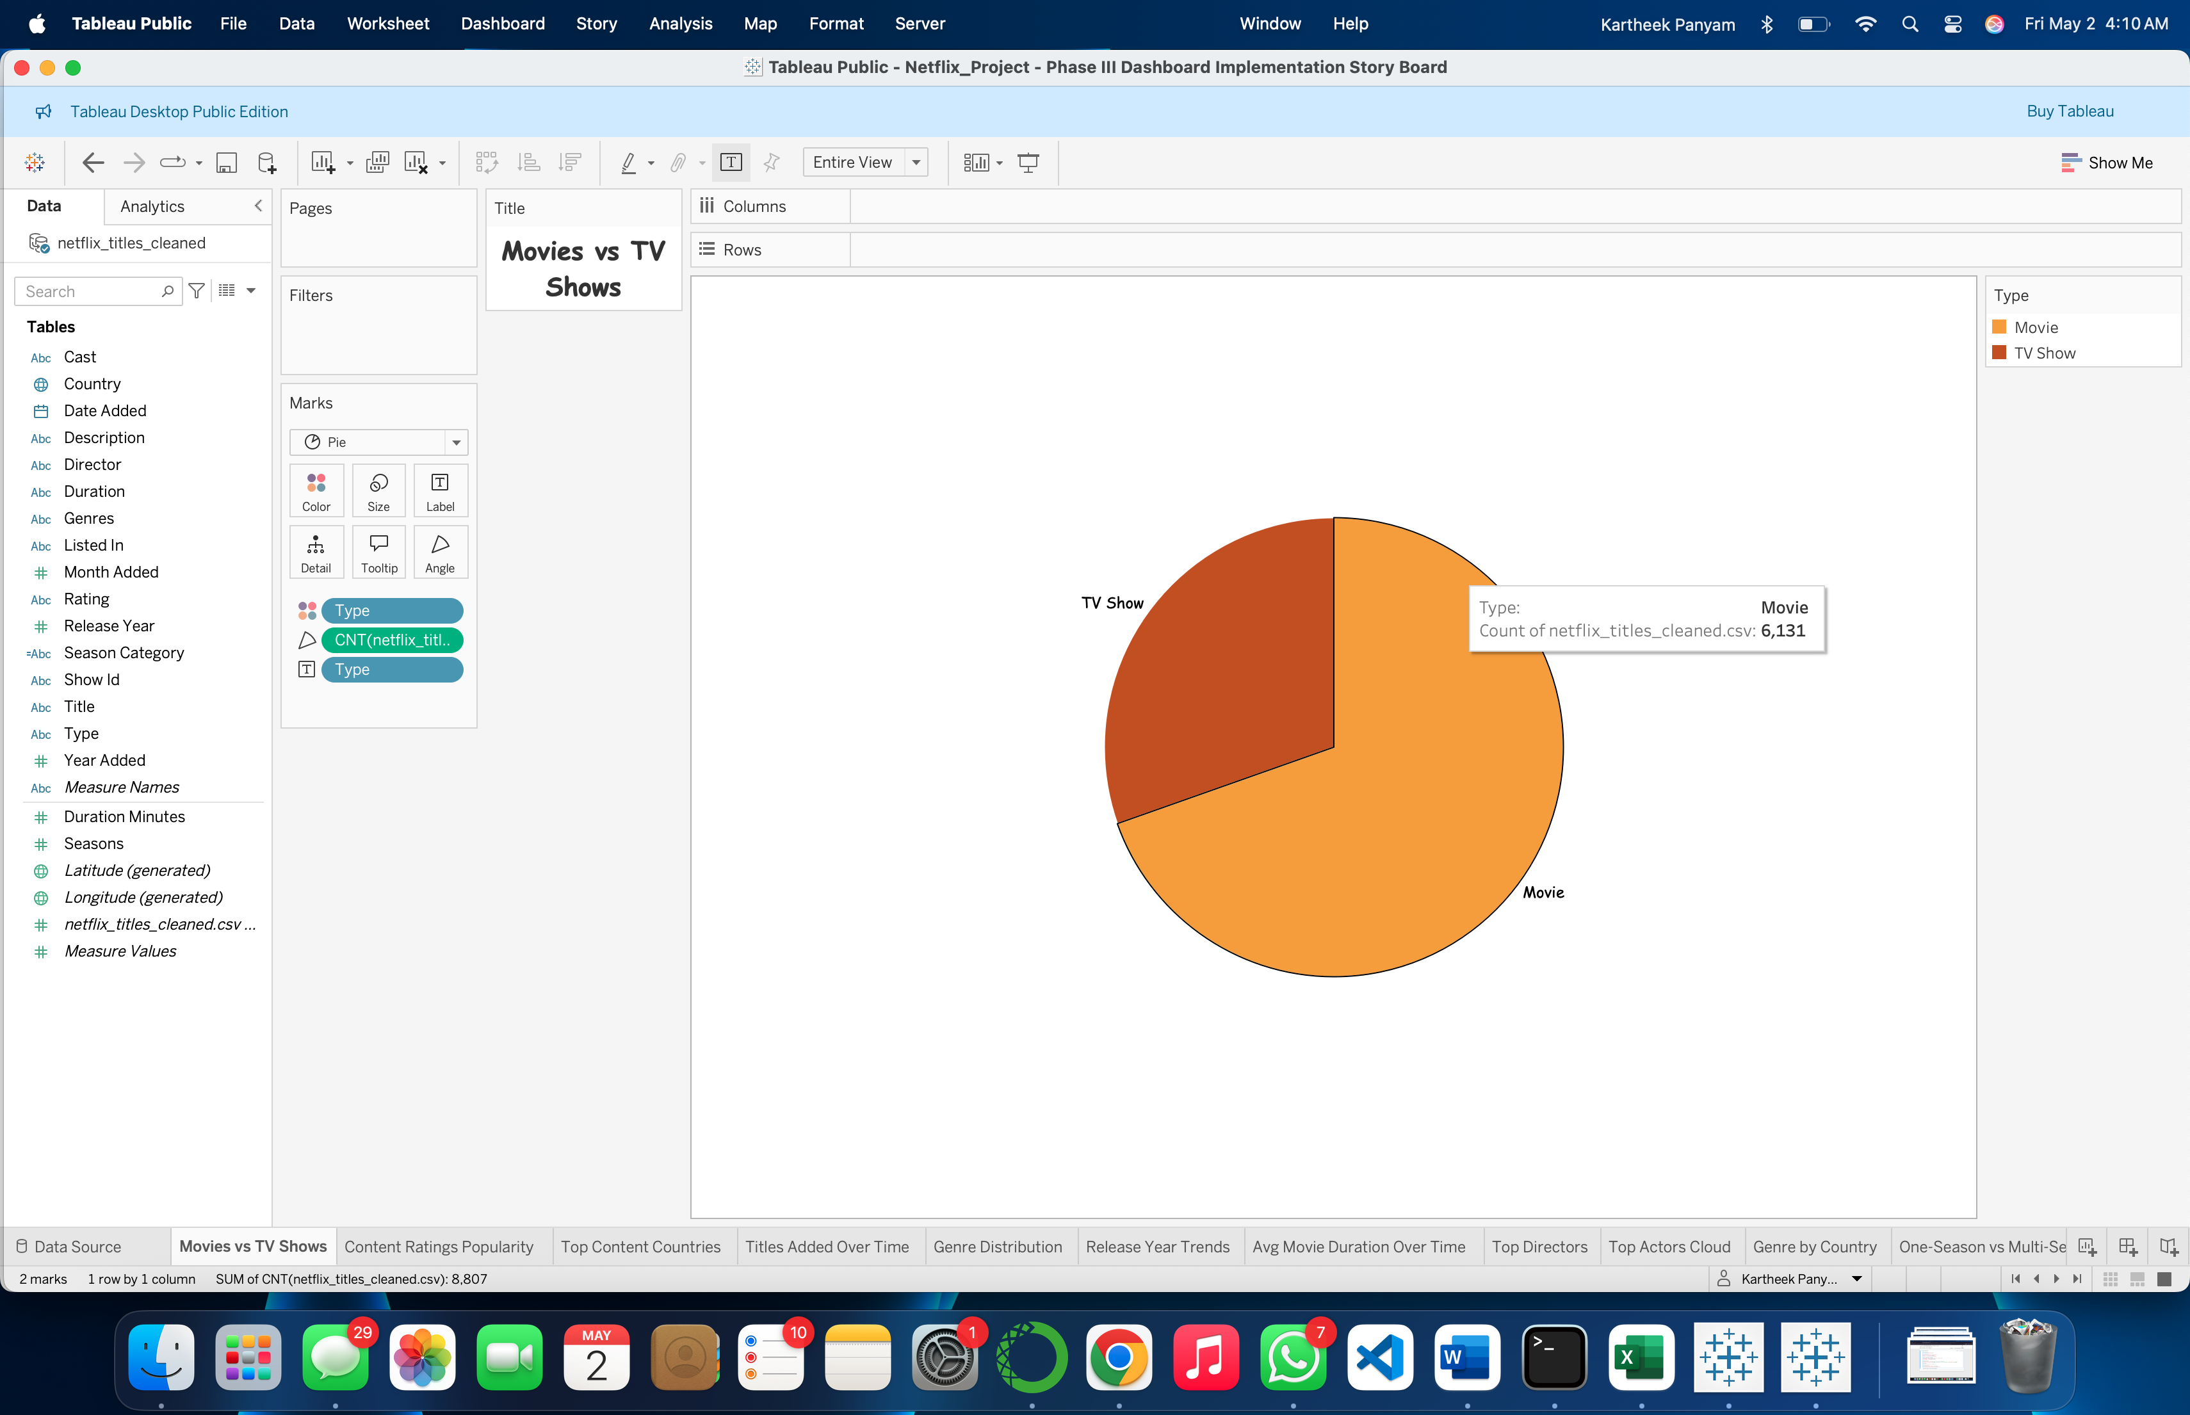  
Q1: How many movies vs. TV shows are on Netflix?

The pie chart shows the percentage and count of Netflix content categorized as either Movie or TV Show. The slice size visually communicates the proportional difference, and data labels provide exact values, offering an immediate breakdown of content types.

1. **Content Ratings Popularity (Horizontal Bar)**

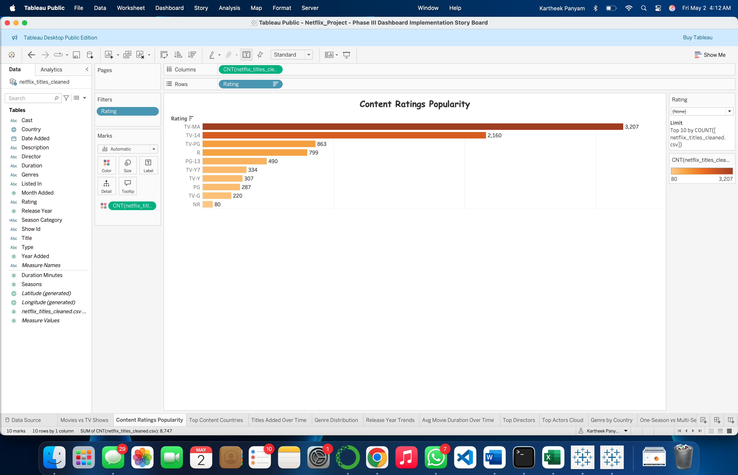  
Q2 & Q11: What are the most popular content ratings?  
How are ratings distributed across movies and TV shows?

The bar chart ranks Netflix content by maturity ratings (e.g., TV-MA, PG, R), displaying the number of titles per rating. Users can use the Type filter to isolate ratings by movies or TV shows, answering both overall and category-specific maturity trends.

1. **Top Content Countries**

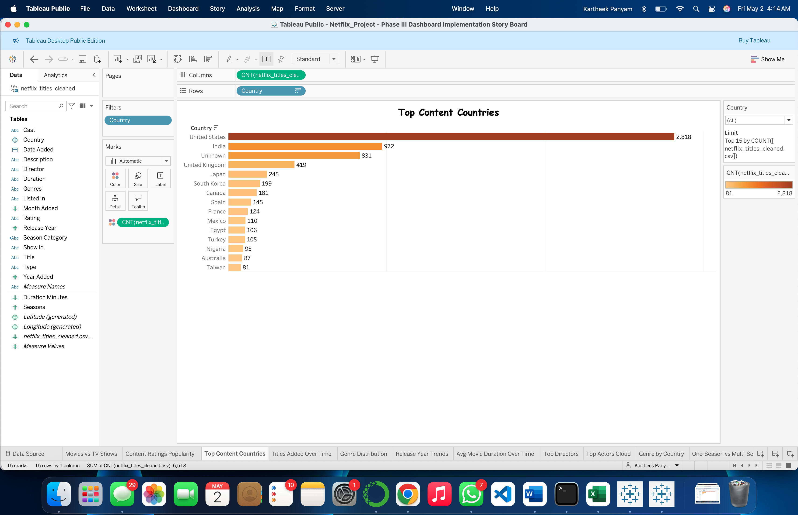  
Q3: Which countries produce the most Netflix content?

This bar chart shows the top 10 countries with the highest content count. Bars are sorted descending, making it easy to identify major content contributors like the U.S. and India.

1. **Titles Added Over Time (Line Chart)**

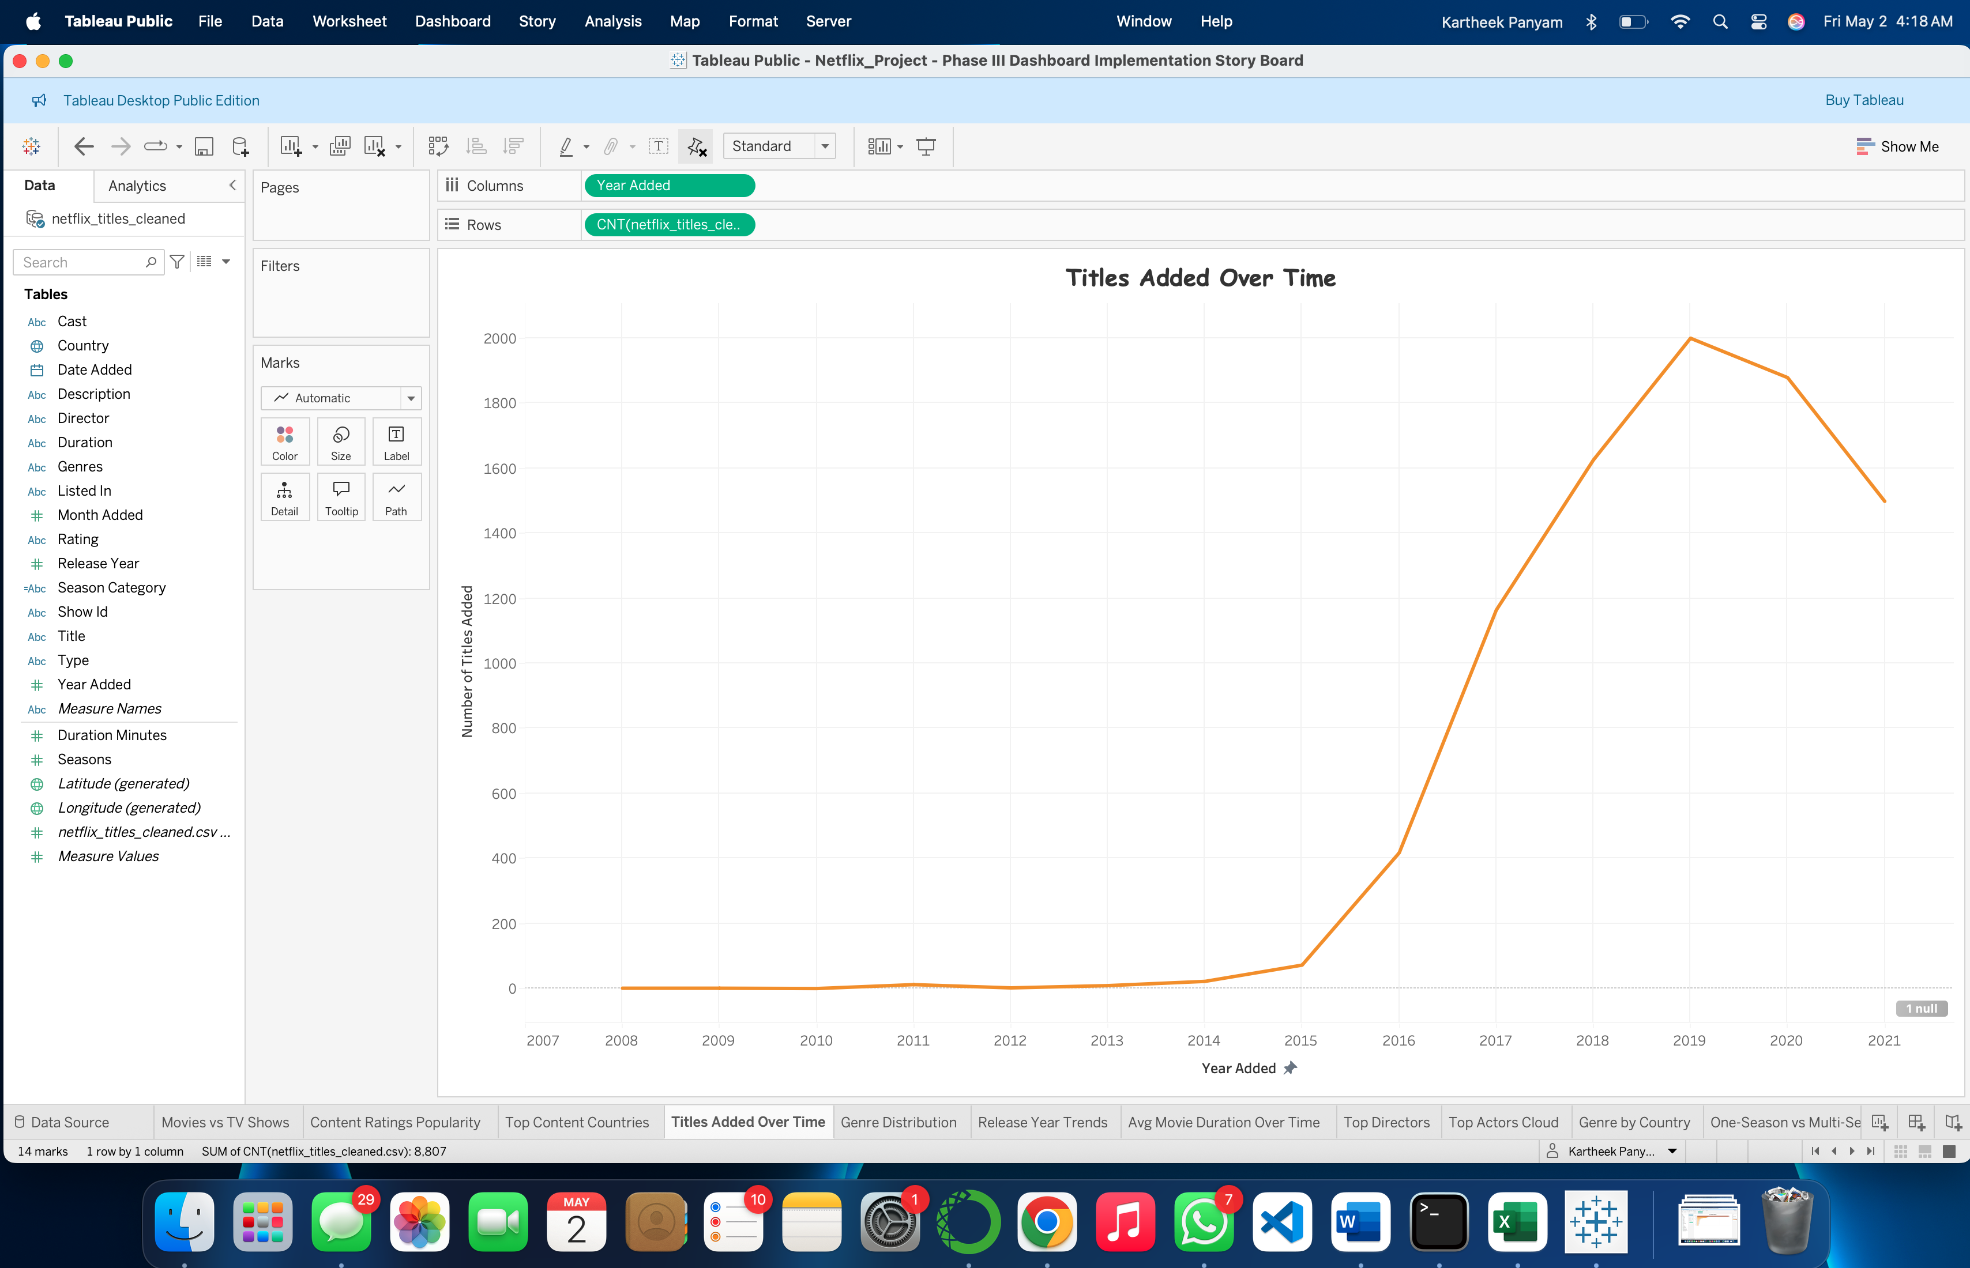  
Q4 & Q12: How has content grown over time?  
Are international titles increasing in recent years?

This line chart tracks the number of titles added per year. It reveals content growth trends over time, including spikes or drops. By applying the Country filter, users can assess the addition of titles from international regions, addressing Q12.

1. **Genre Distribution (Horizontal Bar)**  
   Q5 & Q14: What are the most common genres?  
   What genres are most common among TV vs. movies?

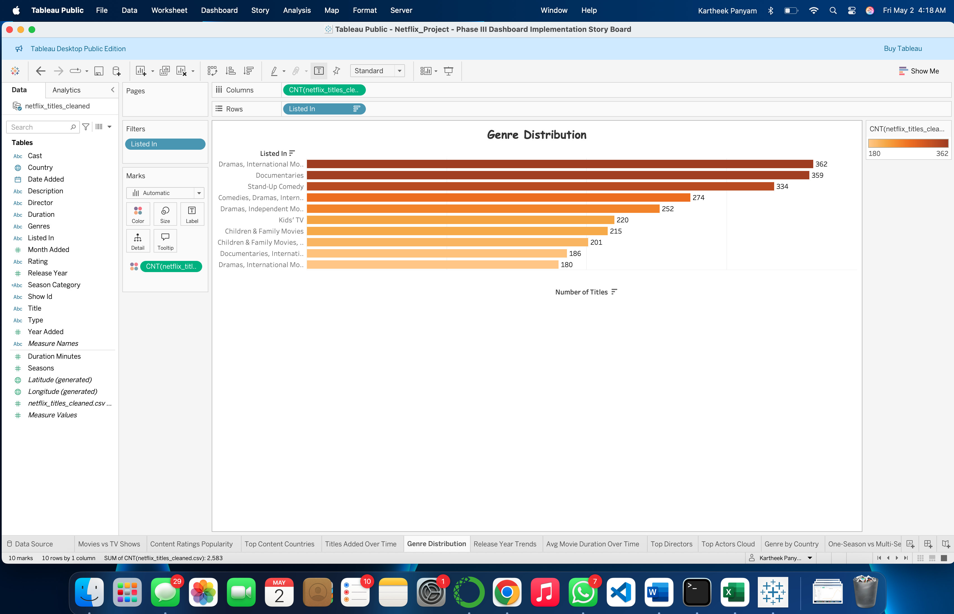

The chart lists genres or genre combinations and their frequency. Using the Type filter (Movie vs TV Show), users can explore which genres dominate per content type, answering both overall and comparative genre questions.

1. **Release Year Trends**

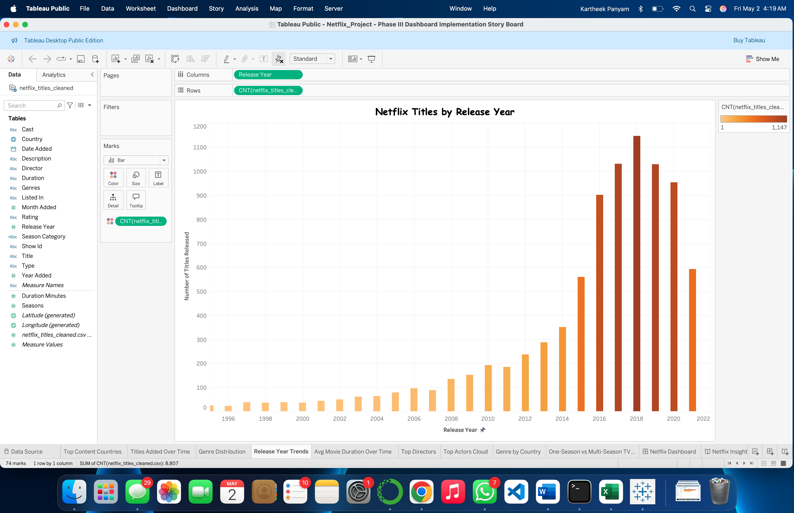  
Q6: Which years had the highest number of releases?

The histogram plots the number of titles released per year (based on the actual release_year). It highlights peaks in production, identifying key release years and trends.

1. **Avg Movie Duration Over Time (Line Chart)**

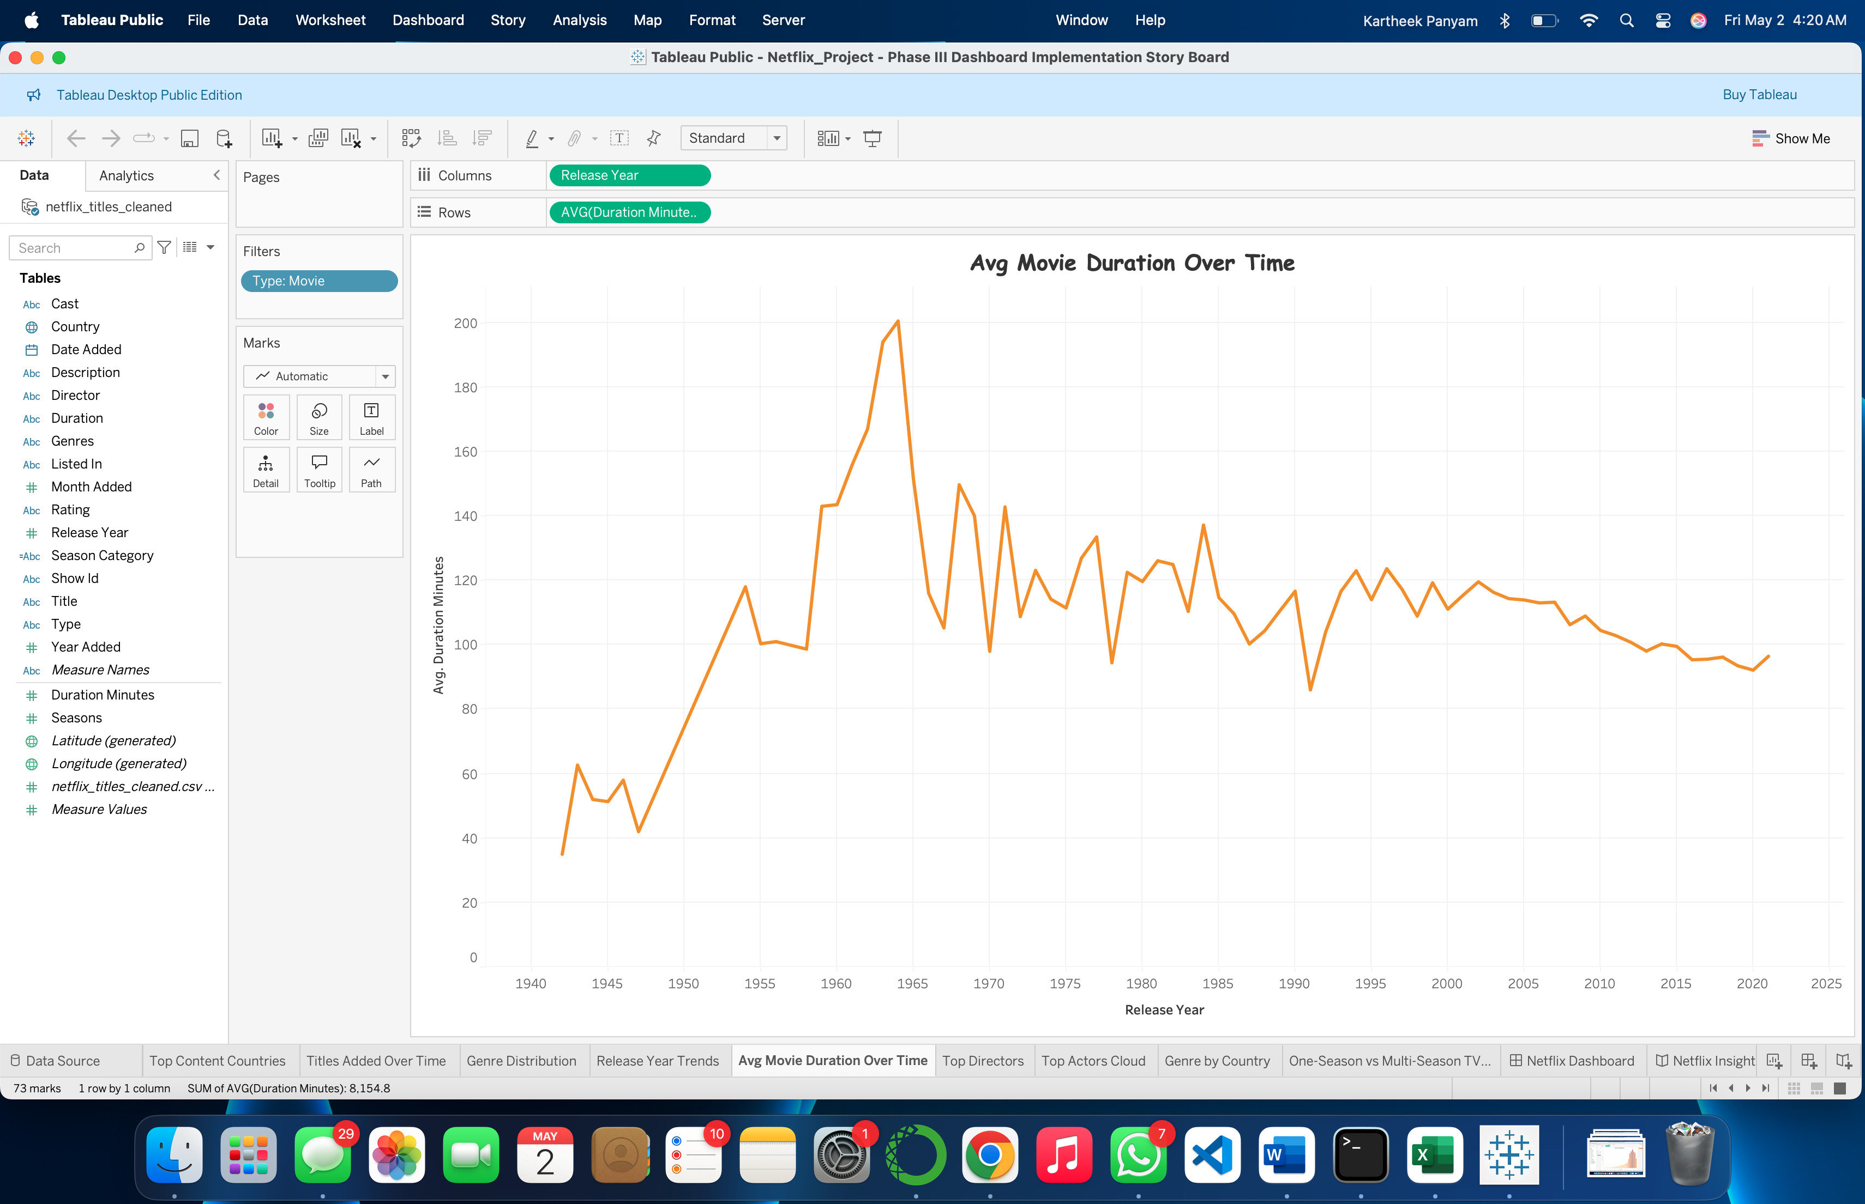  
Q7: What is the average duration of movies by year?

This line chart shows how the average runtime of movies (in minutes) changes across release years. It identifies whether movies are getting longer, shorter, or stable, providing insight into content formatting trends.

1. **Top Directors (Vertical Bar)**

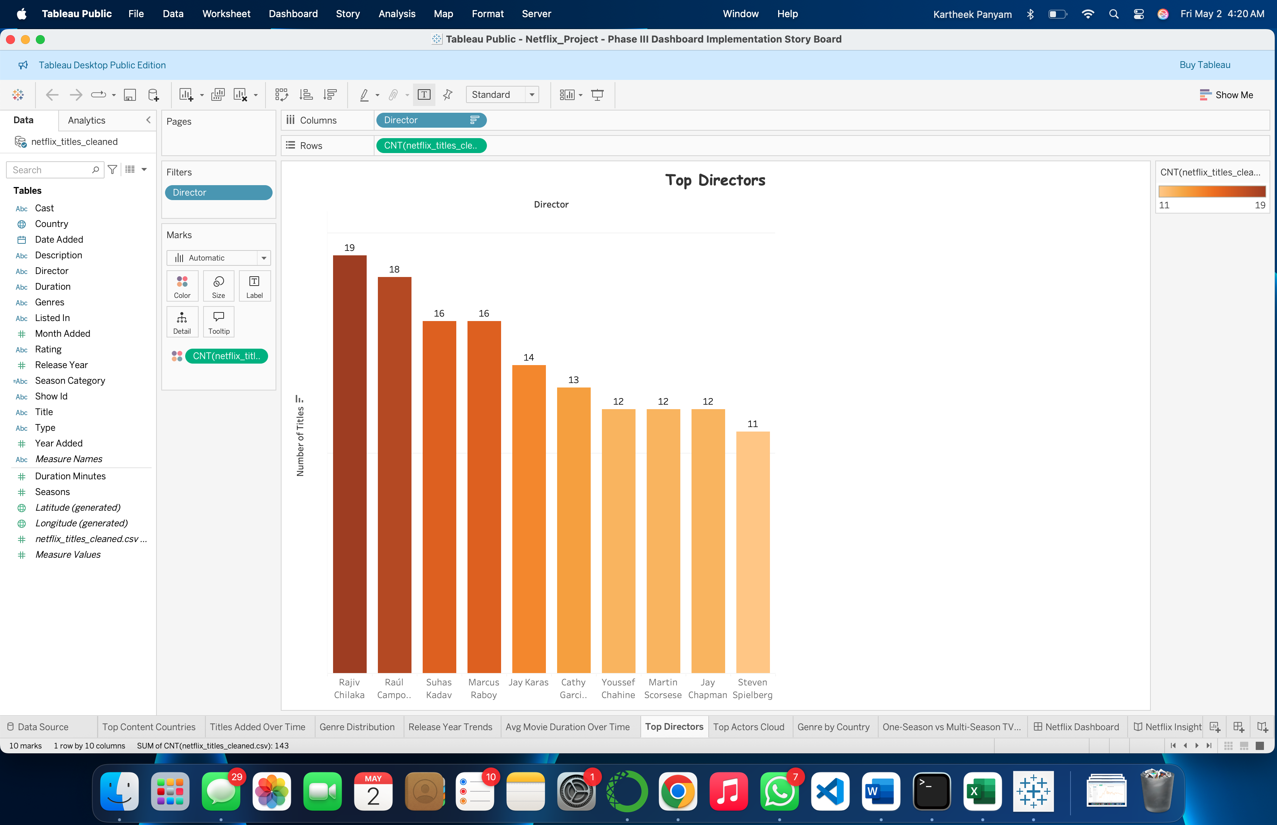  
Q8: Which directors have the most Netflix titles?

This chart ranks directors by the number of titles they’ve contributed. It visually highlights which creators are most prolific on Netflix and may suggest viewer or production preferences.

1. **Top Actors Cloud (Word Cloud)**

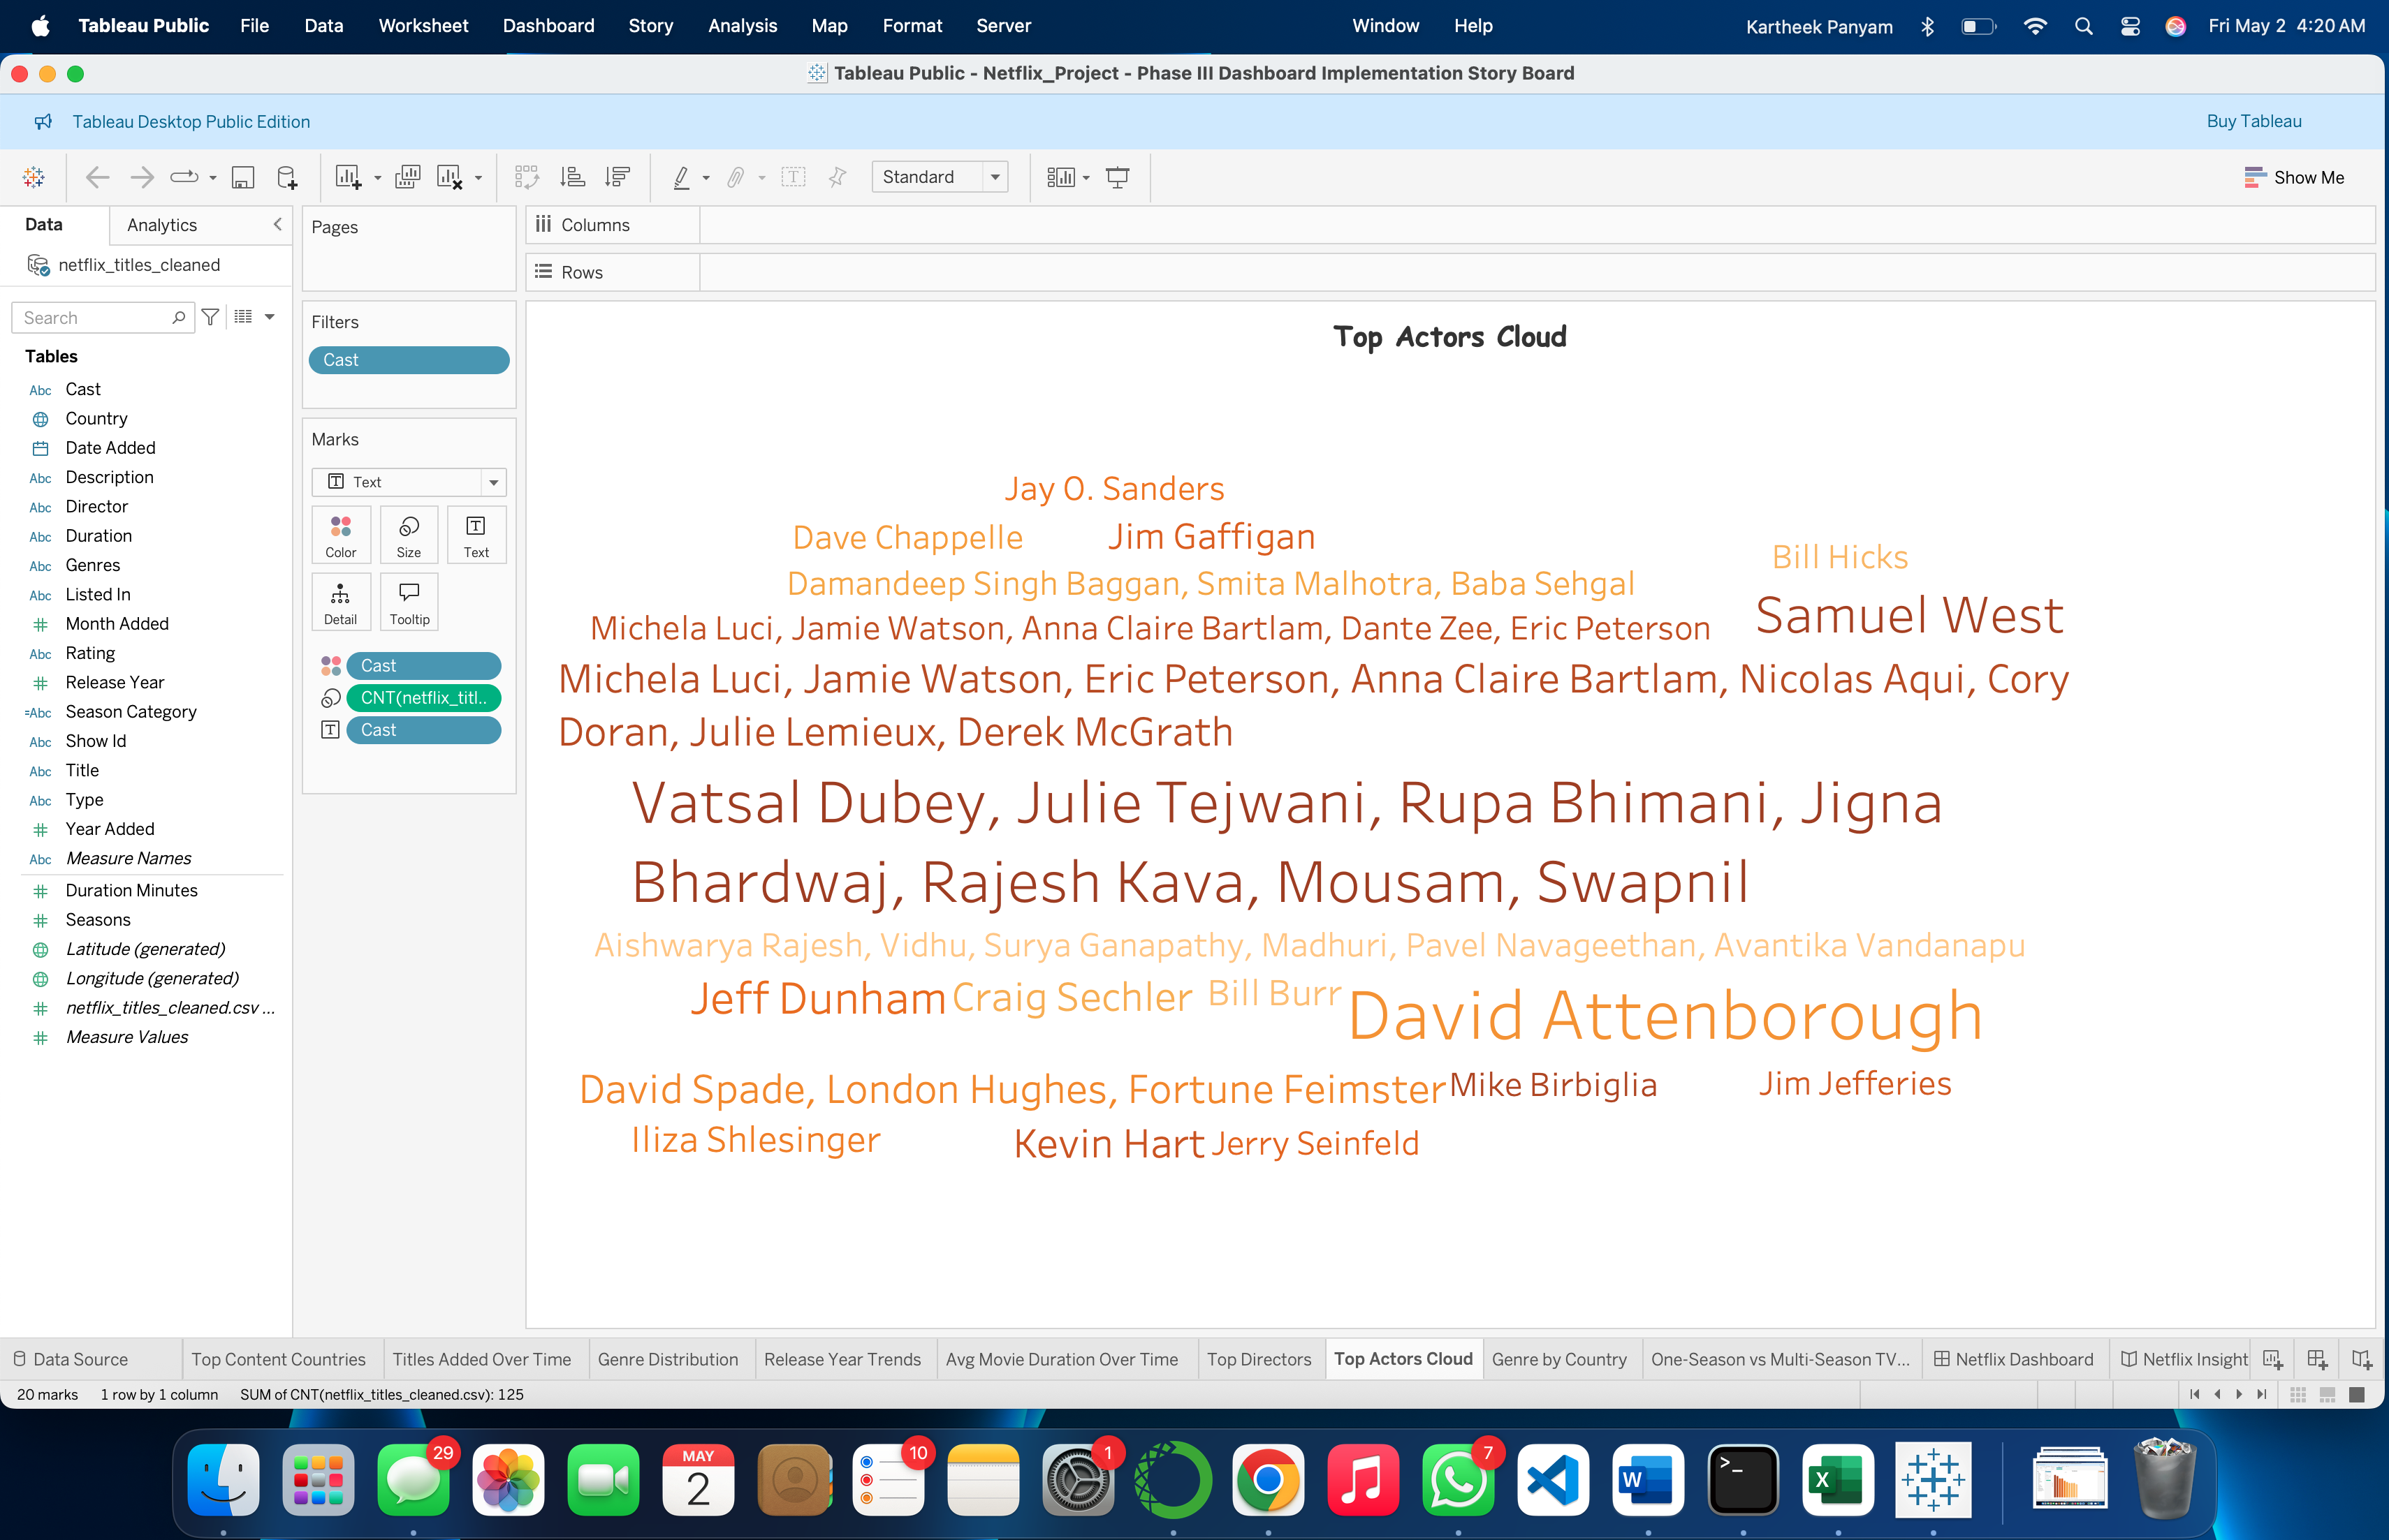  
Q9: Which actors/actresses appear most frequently?

The word cloud represents actors based on their appearance frequency larger names mean more appearances. It provides an at-a-glance summary of prominent on-screen contributors.

1. **Genre by Country (Stacked Bar Chart)**

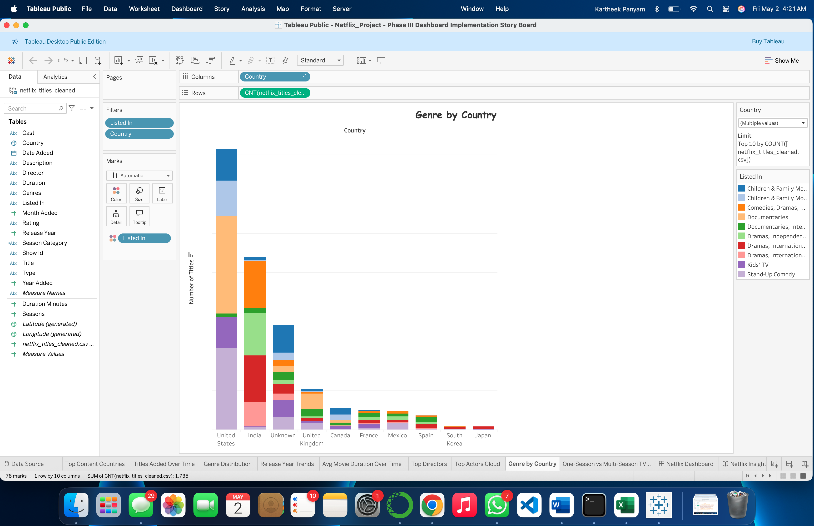  
Q10 & Q15: What genres are preferred by country?  
What are the top countries in each genre?

This stacked bar chart shows genre distribution across selected countries. It reveals cultural preferences and the relative weight of genres within each country, answering both which genres are preferred and how countries contribute to specific genres.

1. **One vs Multi-Season TV Shows (Pie Chart)**

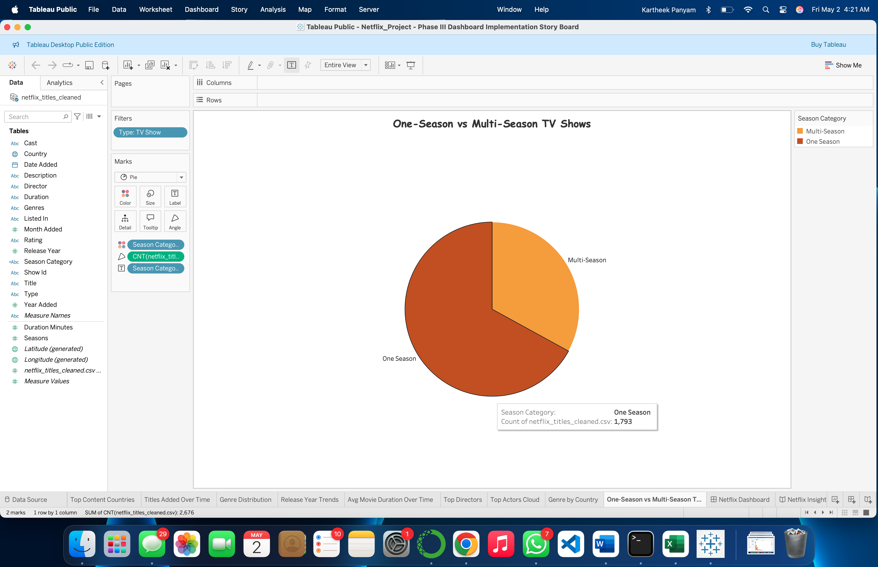  
Q13: How many one-season vs. multi-season shows are available?

The pie chart segments TV shows into “One Season” and “Multi-Season.” It provides a proportional and numerical breakdown of show longevity, useful for understanding Netflix’s approach to limited series vs. serial content.

**Section 6: Interactivity**

We implemented several interactive controls in Tableau:

* **Content Type Filter** (Movies vs TV Shows): Connected to multiple charts for isolating content types.
* **Release Year Range Slider**: Allows temporal filtering from 1925 to 2021 on release-year-related visuals.
* **Genre Multi-Select**: Filters charts by genre categories (e.g., Comedies, Documentaries).
* **Country Selector**: Lets users focus on specific countries to compare content output or genre mix.
* **Rating Selector**: Enables filtering titles based on maturity ratings like PG, TV-MA, etc.

Together, these controls allow multidimensional exploration and provide users with a personalized insight discovery experience.

**Please note that we have also implemented story board as we mentioned in phase 2:**

**Story Board URL:** [**https://public.tableau.com/views/Netflix_Project-PhaseIIIDashboardImplementationStoryBoard/NetflixInsightsStory?:language=en-US&publish=yes&:sid=&:display_count=n&:origin=viz_share_link**](https://public.tableau.com/views/Netflix_Project-PhaseIIIDashboardImplementationStoryBoard/NetflixInsightsStory?:language=en-US&publish=yes&:sid=&:display_count=n&:origin=viz_share_link)

**References**

**1. Netflix Movies and shows Dataset:** <https://www.kaggle.com/datasets/shivamb/netflix-shows>

**2. Mural link:** [**https://app.mural.co/t/ift5338876/m/ift5338876/1744948618212/1841962e5e3801a8ff05bc1b200746c861dcb20b**](https://app.mural.co/t/ift5338876/m/ift5338876/1744948618212/1841962e5e3801a8ff05bc1b200746c861dcb20b)

**3. Dashboard URL:** [**Netflix_Project-PhaseIIIDashboardImplementation**](https://public.tableau.com/views/Netflix_Project-PhaseIIIDashboardImplementation/NetflixDashboard?:language=en-US&publish=yes&:sid=&:redirect=auth&:display_count=n&:origin=viz_share_link)

**4. Story Board URL:** [**https://public.tableau.com/views/Netflix_Project-PhaseIIIDashboardImplementationStoryBoard/NetflixInsightsStory?:language=en-US&publish=yes&:sid=&:display_count=n&:origin=viz_share_link**](https://public.tableau.com/views/Netflix_Project-PhaseIIIDashboardImplementationStoryBoard/NetflixInsightsStory?:language=en-US&publish=yes&:sid=&:display_count=n&:origin=viz_share_link)